CISA Zero Trust Compliance for Log360
Ensure healthcare security and CISA Zero Trust compliance with Log360.
Region: USA | Type: Cybersecurity Framework, Healthcare, Government/Public Sector, Zero Trust | Category: Compliance | Pricing: Free

Overview
The CISA Zero Trust compliance extension in Log360 helps organizations meet the CISA Zero Trust Maturity Model (Version 2.0, US), the official US government roadmap backed by Executive Order 14028 and OMB M-22-09 mandating zero trust adoption for federal agencies by providing centralized log management, continuous identity verification, device health tracking, and network analytics. The platform supports CISA Zero Trust requirements for identity verification, device compliance, network segmentation, application access, data security, visibility and analytics, and privileged access governance.
For Identity Pillar: Continuous Identity Verification, Log360 monitors all authentication events to detect anomalous access patterns that signal zero trust policy violations. To address Device Pillar: Device Compliance and Endpoint Security, the platform provides continuous endpoint security monitoring to ensure only compliant devices access protected resources. The extension also supports Network Pillar: Segmentation and Traffic Monitoring by providing capabilities that aggregates network logs to detect lateral movement, unauthorized traffic, and firewall policy violations.

Key Features
- Application Pillar: Access Control and Workload Security: Log360 monitors application logon events, query activity, and unauthorized database operations across all workloads.
- Data Pillar: Data Security and Information Protection: Log360 tracks data access events, file modifications, and exfiltration attempts to enforce data-centric zero trust controls.
- Visibility, Analytics, and Automation: Log360 consolidates all security telemetry and enables automated alerting to support zero trust decision engines.
- Privileged Access and Zero Trust Policy Enforcement: Log360 monitors all privileged actions across PAM platforms, Active Directory, and cloud identity providers.
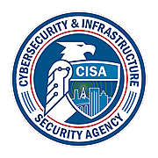
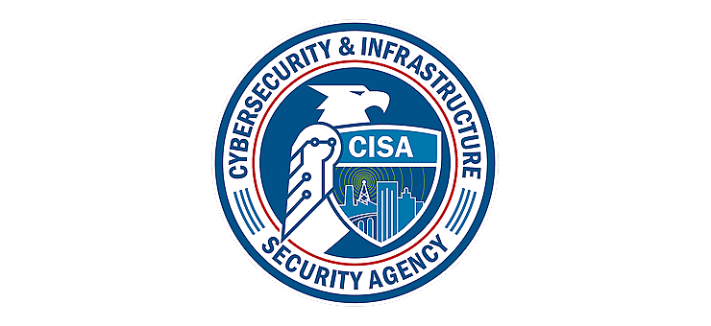
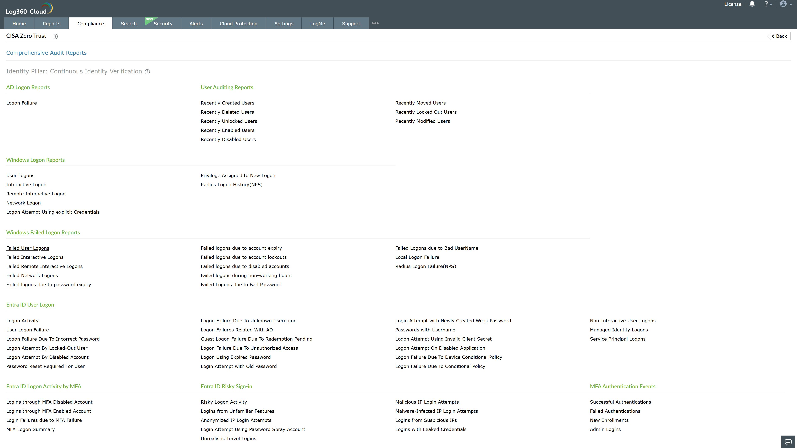
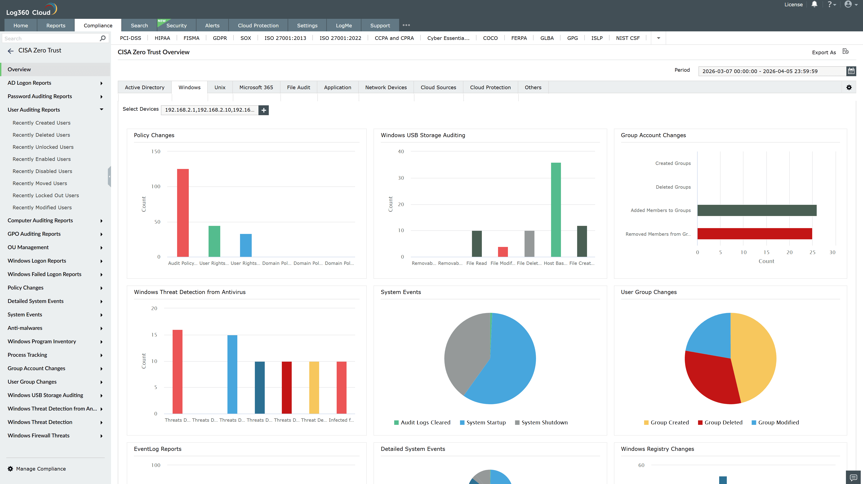
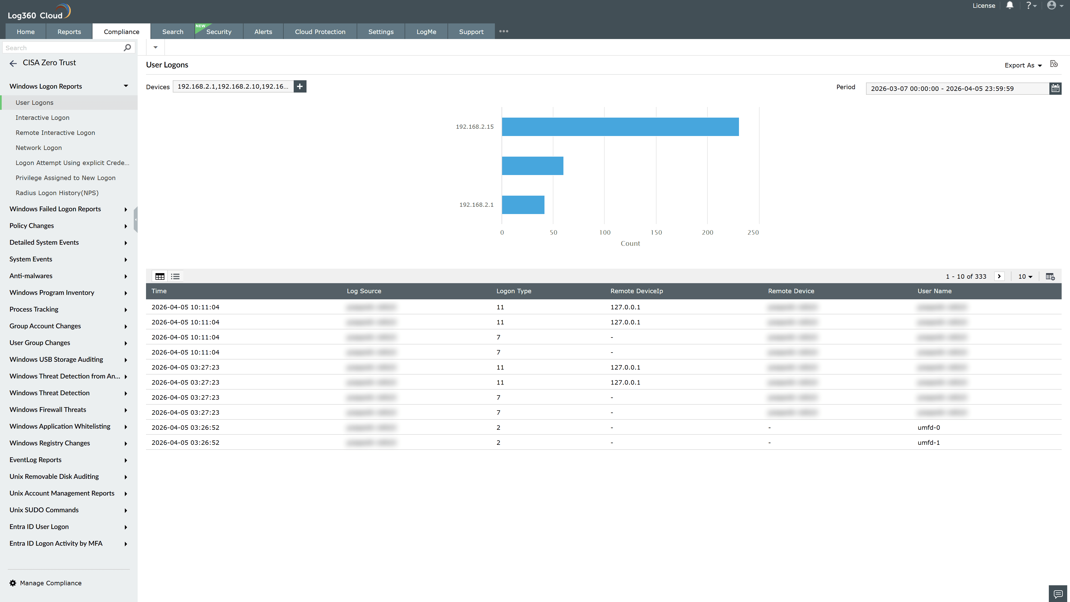
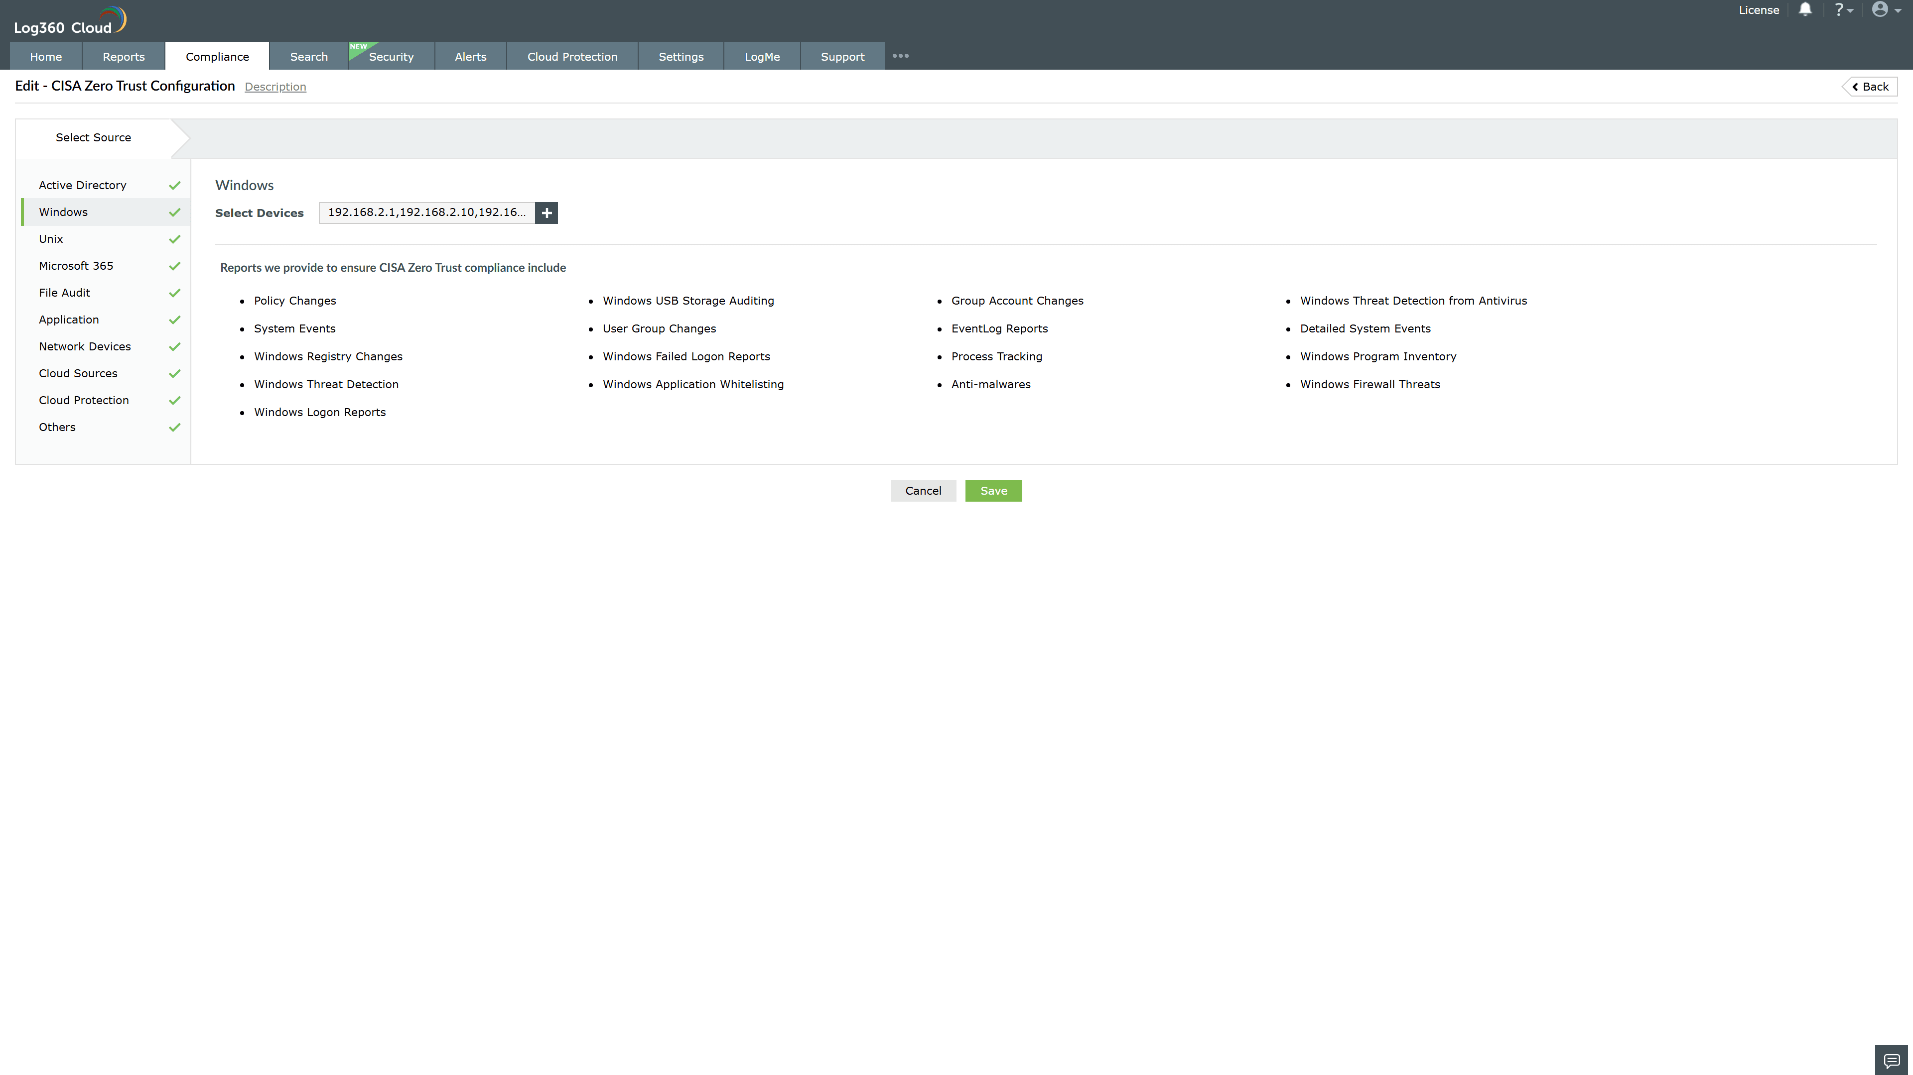
Valid Submission : Yes
Supported Editions : Free, Basic, Standard, Professional, MSSP
Help Document : https://www.manageengine.com/log-management/help/integrations/compliance-extensions.html
Help Video : Not provided
Tags : Log360, Compliance, Privacy monitoring, Data privacy, Regulatory compliance
Supported DCs : US, IN, JP, CA, AU, UK and EU
Privacy Policy:
Terms of Service:
Release Notes:
Predefined reports for the CISA Zero Trust.

